You can choose one of these four problems to finish:

**Problem 1:**

Write a system to read the point cloud data about the human body and show it. At the same time your system must meet the following requirements:

1. The human body model must can be moved up and down or left and right by pressing the keyboard.
2. The human body model must can be rotated and zoomed in and out by using the keyboard and mouse buttons.
3. In light source part, you need to achieve point lights and spotlight effect. Besides the type and the parameter of the light source need to be changed by using the keyboard.

**Problem 2:**

Write a system to simulate the solar system, including the sun and the eight planets in the solar system. Your system must meet the following requirements:

1. In the system, you need to consider the appearance, size, speed and rotation of the sun and the eight planets in the solar system.
2. In the system, the solar system needs to be moved up and down or left and right by using the keyboard. Also, the rotation speed of the star and the planets and the end of the whole solar system need be controlled by keyboard.
3. You’d better consider that the sun is glowing and the sunlight will influence the brightness of the other planets. Also, you should take the planet’s reflection of light needs into consideration.

**Problem 3:**

Write a system to realize a 3*3 magic cube. At the same time your system must meet the following requirements:

1. By using the mouse, the whole magic cube needs to be rotated. And by using the mouse and the keyboard, the row or the column of the magic cube needs to be rotated.
2. You need to make an animation about the rotation of the whole magic cube, the row of the magic cube and the column of the magic cube.
3. The texture of the magic cube needs to be changed by keyboard. Also, you need to achieve point lights and spotlight effect. Besides the type and the parameter of the light source need to be changed by using the keyboard.

**Problem 4:**

You will be implementing the method as described in the paper by Beier & Neely's 1992 paper on "Feature Based Image Metamorphosis". Given two source images, I0 and I1, the user specifies a set of corresponding lines in them to establish correspondence between "features" in one image and "features" in the other. The main component of the morphing technique is an image warping algorithm called **Field Warping** that you will have to implement.

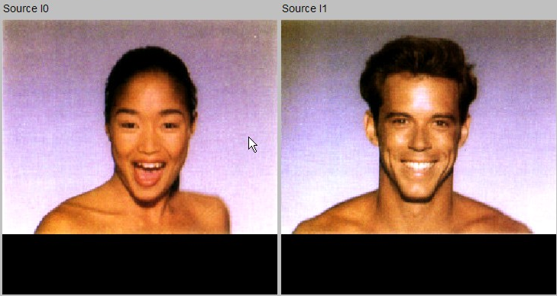

**Source image**

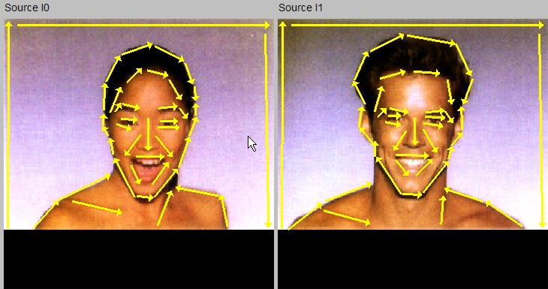

**The interpolated lines overlayed**

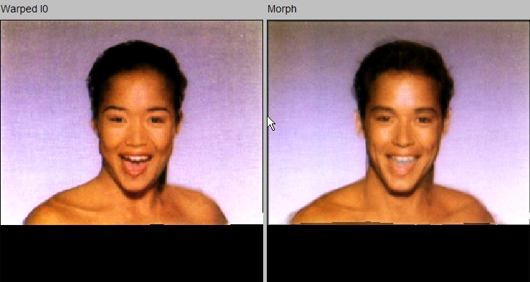

**Result image**

In this problem you should complete the following tasks:

1. Read the paper “Feature Based Image Metamorphosis” and two other papers

about it;

(2) Read the code and implement **morphing.field_warp()** and **morphing.compute_morph()** in file morphing_algorithm.cxx and debug your program. To help debug your warping implementation, you are being provided with two test images called checker1.tif and checker2.tif. These images show a checker board pattern and should help in visualizing how specific parts of the image plane are warped by your field warping implementation.

(3) Use the couple0.jpg and couple0.jpg to test your program.

(4) Grab some pictures of your own to test the capabilities of your morphing implementation.